# CHANAKYA UNIVERSITY

## NAME: Keerthana S Nayak

## REG NO : 24UG00439

Fitness Club

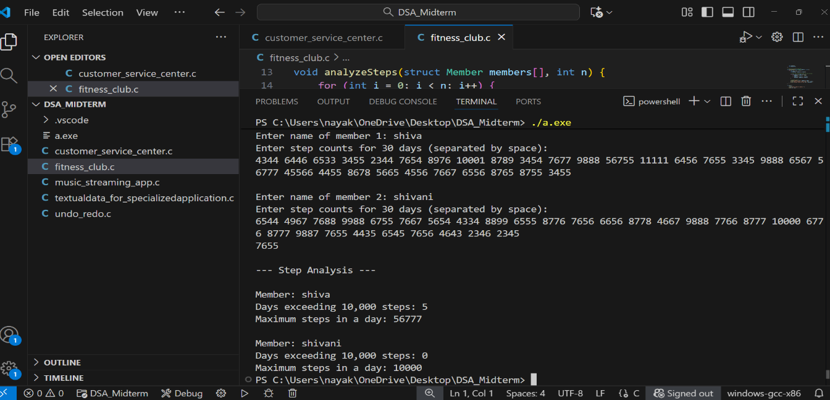

Textual Data for Specialized Application

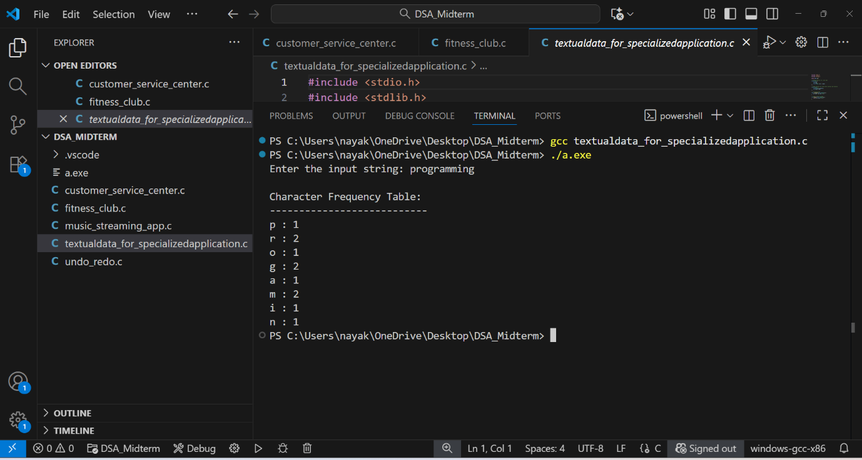

Undo Redo

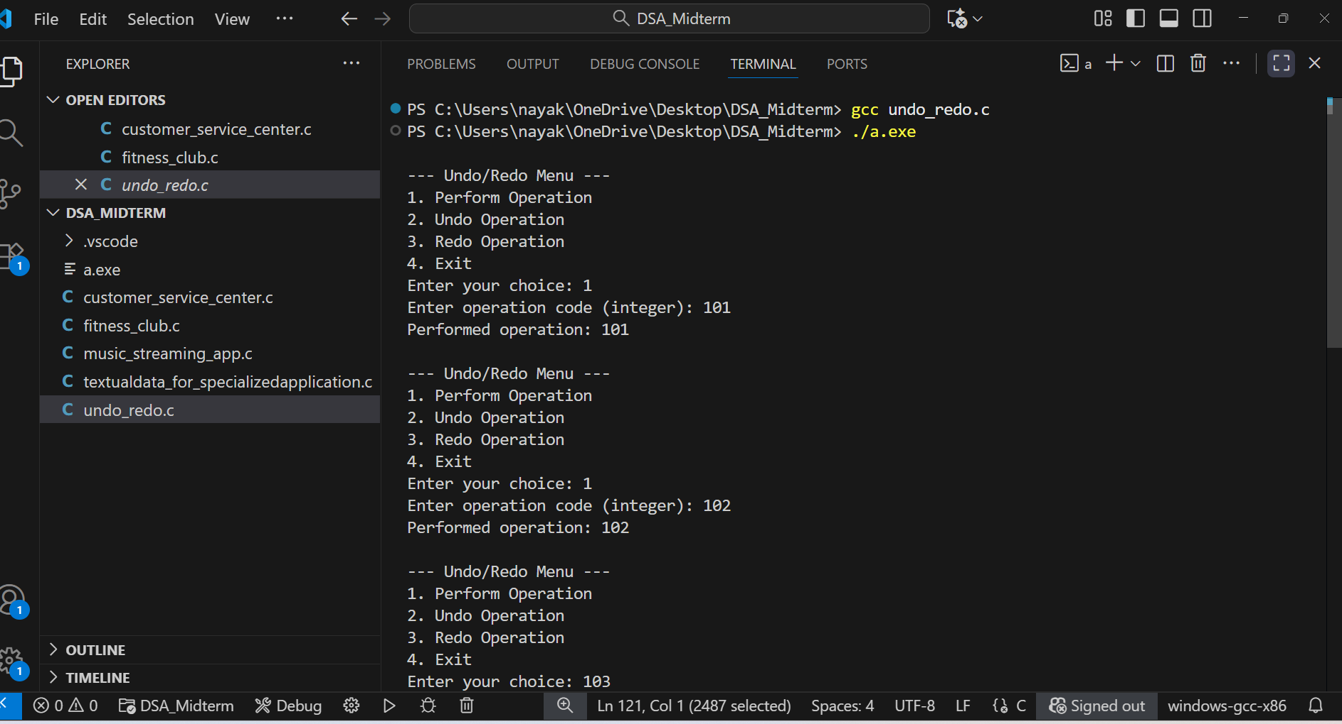

Customer Service Center

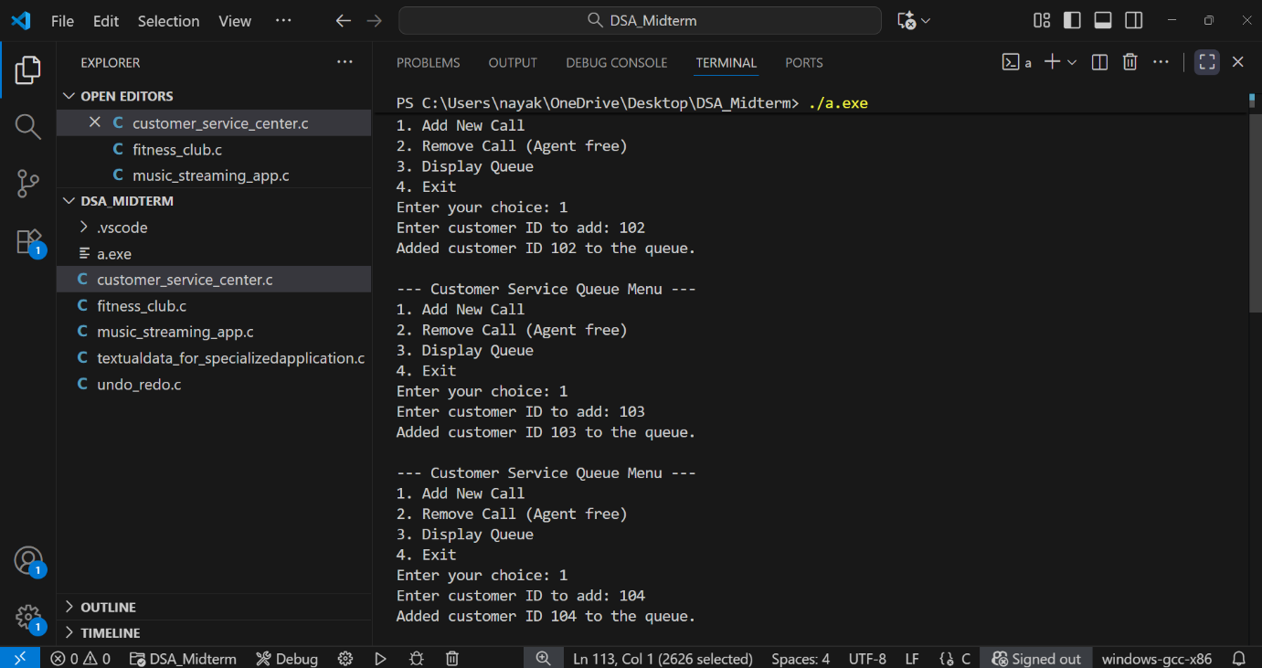

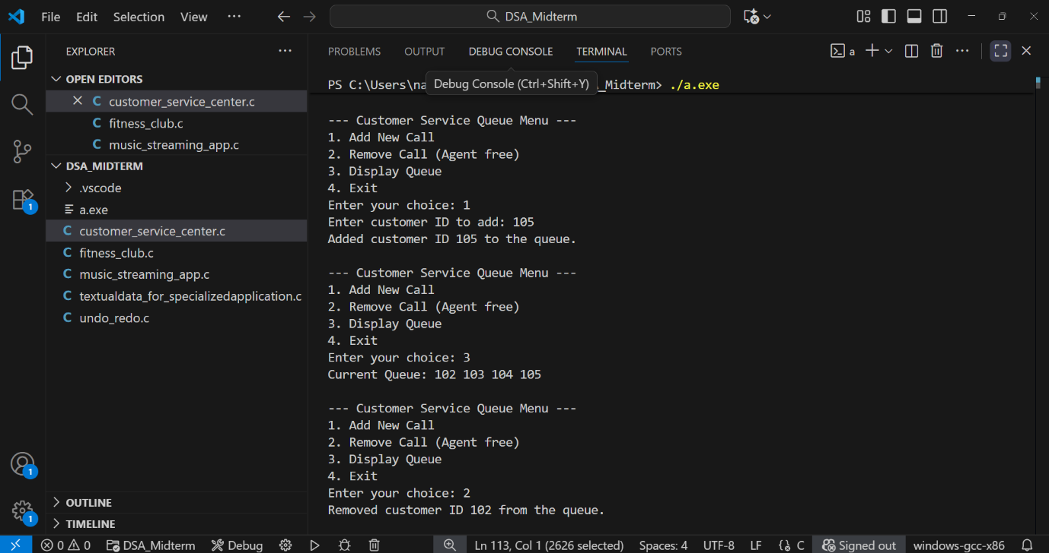

Music Streamimg App

